**Important aspects regarding validation**

* On/off controller – if the temperature at the exit of the solar collector (Tcout) is higher than the temperature of layer 8 of the storage tank (last layer exchanging heat with the solar collector) the pump switches on.
* Heat demand for the storage tank

The same flow rate profile every day

 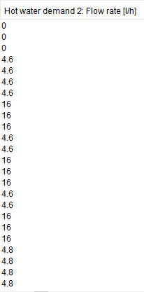

* Equations of the storage tank - Based on [1] and [2]

T1 and T12 have higher volume because it includes the bulge.

|  |  |
| --- | --- |
| **Temperature in the layer** | **Equation** |
| T1 | (1) |
| T2,T3,T4,T9,T10,T11 | (2) |
| T5,T6,T7,T8 | (3) |
| T12 | (4) |

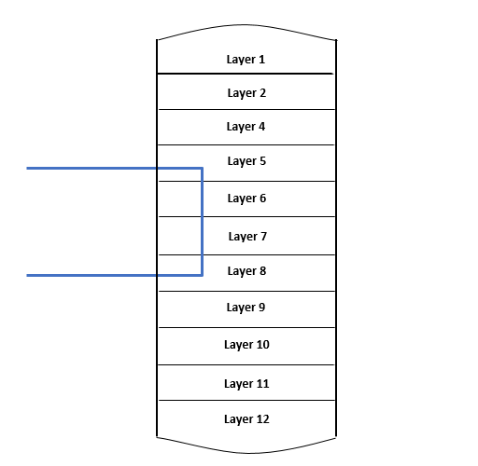

$\frac{dT}{dt}= \frac{\dot{V}}{V_{tank}} \left(T_{j+1}-T_{j}\right)-\frac{U_{loss}A_{tank+ts}}{ρcV_{tank}}\left(T_{j}-T_{a}\right)+ \frac{k_{j1}A_{c}}{ρcV_{tank}∆x}\left(T_{j+1}-T_{j}\right)$ (1)

$\frac{dT}{dt}= \frac{\dot{V}}{V_{tank}} \left(T_{j+1}-T_{j}\right)-\frac{U_{loss}A_{tank}}{ρcV_{tank}}\left(T_{j}-T_{a}\right)+ \frac{k_{j1}A_{c}}{ρcV_{tank}∆x}\left(T_{j+1}-T_{j}\right)+\frac{k_{j2}A_{c}}{ρcV_{tank}∆x}(T_{j-1}-T_{j})$ (2)

$\frac{dT}{dt}= \frac{\dot{V}}{V_{tank}} \left(T_{j+1}-T_{j}\right)-\frac{U_{loss}A_{tank}}{ρcV_{tank}}\left(T_{j}-T_{a}\right)+ \frac{k_{j1}A_{c}}{ρcV_{tank}∆x}\left(T_{j+1}-T_{j}\right)+\frac{k_{j2}A_{c}}{ρcV_{tank}∆x}\left(T_{j-1}-T_{j}\right) –\dot{Q}coil$ (3)

With $\dot{Q}coil= \frac{U_{solar}A_{coil}}{ρcV_{tank}}\left(T_{j}-T_{cini}\right)$

$\frac{dT}{dt}= \frac{\dot{V}}{V_{tank}} \left(T_{in}-T_{j}\right)-\frac{U_{loss}A_{tank}}{ρcV_{tank}}\left(T_{j}-T_{a}\right)+\frac{k_{j2}A_{c}}{ρcV_{tank}∆x}(T_{j-1}-T_{j})$ (4)

$k_{j1}= \left\{\begin{aligned}k_{j1}∆\left|T_{j+1}-T_{j}\right| if T_{j}< T_{j+1} \\ k_{j1} else\end{aligned} \right.$ (5)

$k_{j2}= \left\{\begin{aligned}k_{j2}∆\left|T_{j-1}-T_{j}\right| if T_{j-1}< T_{j} \\ k_{j2} else\end{aligned} \right.$ (6)

Variables:

$$V_{tank}-Volume of the layer considered (m^{3})$$

$$\dot{V}-Flow rate that exists the tank (\frac{m^{3}}{s})$$

$$T_{j}-Temperature of the layer j (ºC)$$

$$T_{j+1},T_{j-1}-Temperature of the previous,next layer (ºC)$$

$$T_{cini}- Temperature at the exit of the coil in contact with the layer j \left(ºC\right) (see figure)$$

$$A_{tank}-Lateral area of the tank in contact with the layer (m^{2})$$

$$A_{tank+ts}-Area of the lateral tank in contact with the layer plus area of the top section of the tank (m^{2})$$

$$U_{solar}- Heat transfer coefficient between the fluid in the solar coil and the fluid of the layer \left(considered constant\right) (W/(m^{2}*K)$$

$$U_{loss}- Heat transfer coefficient between the fluid in the storage tank and atmospheric air \left(considered constant\right) (W/(m^{2}*K)$$

$$κ_{j}-thermal conductivity of the water in the layer j (W/(m*K))$$

$Δ-Constant that is several orders of magnitude higher than the thermal conductivity$ (To force the heat to go from the layer below to layer j) (see bibliography).

$$∆x-Height of the layer (m)$$

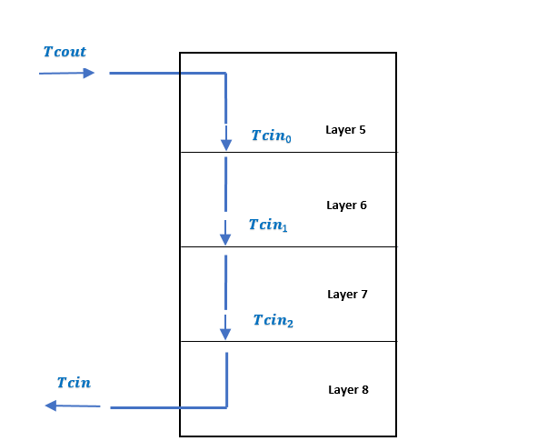

Bibliography

[1] A. Rahman, N. Fumo, and A. D. Smith, “Simplified modeling of thermal storage tank for distributed energy heat recovery applications,” *ASME 2015 9th Int. Conf. Energy Sustain. ES 2015, collocated with ASME 2015 Power Conf. ASME 2015 13th Int. Conf. Fuel Cell Sci. Eng. Technol. ASME 2015 Nucl. Forum*, vol. 2, no. June, 2015, doi: 10.1115/ES2015-49170.

[2] A. L. Nash, A. Badithela, and N. Jain, “Dynamic modeling of a sensible thermal energy storage tank with an immersed coil heat exchanger under three operation modes,” *Appl. Energy*, vol. 195, pp. 877–889, 2017, doi: 10.1016/j.apenergy.2017.03.092.